ASSIGNMENT-2 DOCKER (PIPELINE)
EC2 ├── Java 21
├── Git
├── Docker
└── Jenkins
│
├── Q1 → Docker → :81
├── Q2 → Docker → :90
└── Q4 → Docker → :8081
AND TEST -------- http://EC2-IP:81
--------- http://EC2-IP:90
---------- http://EC2-IP:8080

1)REPO----2026Q1MR
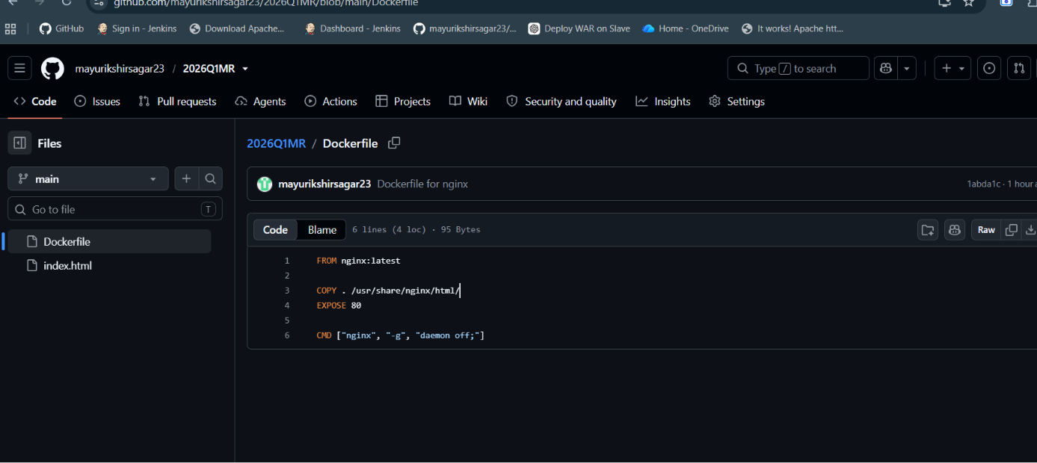

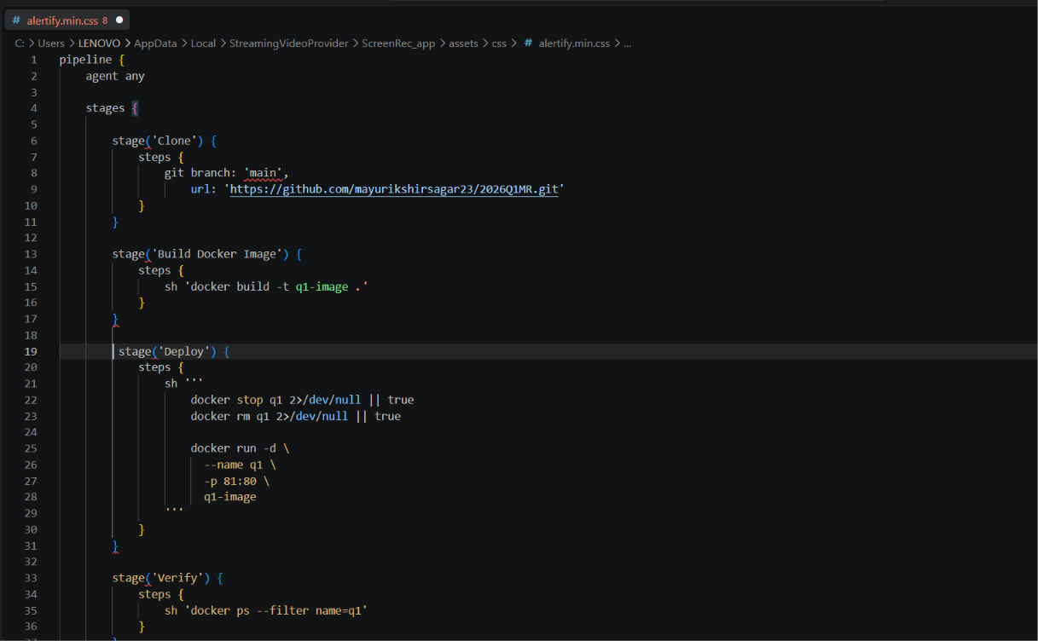
2)PIPELINE SCRIPT -IN JENKINS –Q1-PIPELINE

3)SUCESSFULLY BUILD IN JENKINS
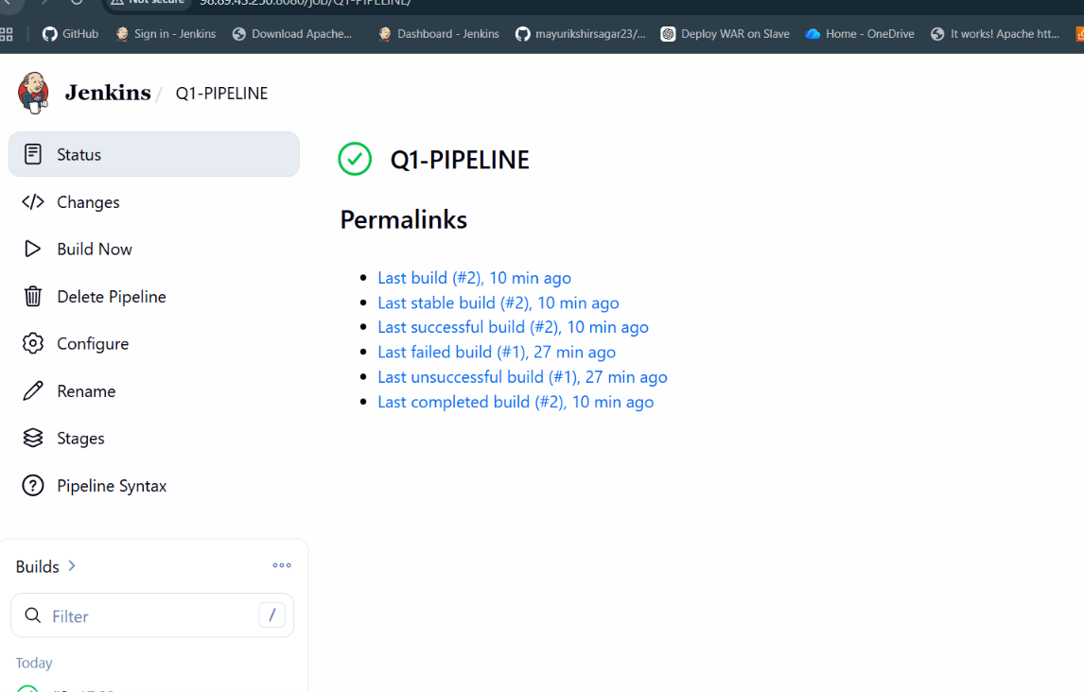
4)CHECKED ON EC2 q1 IMAGED WAS FORMED AUTOMATIC FROM JENKINS BUILD
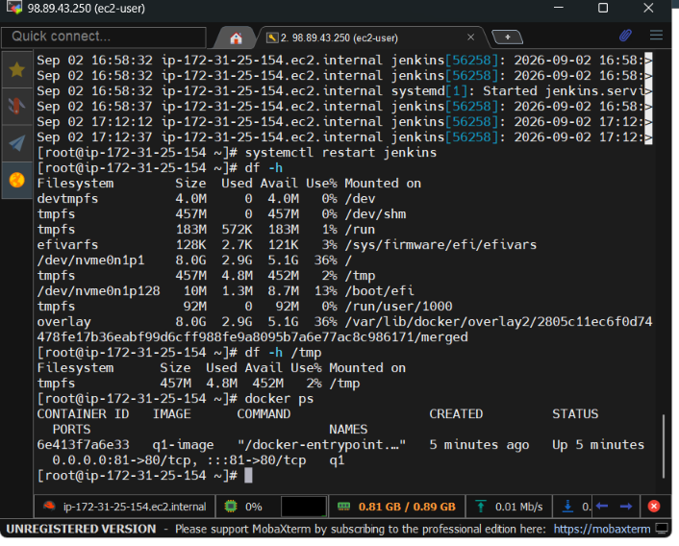
5)CHECKED ON BROWSER WITH- http://PUBLIC-IP:81

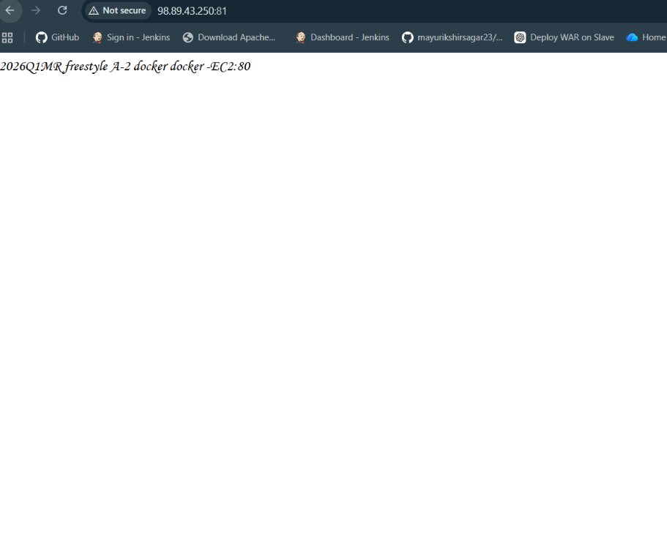
2)REPO -------2026Q2PR
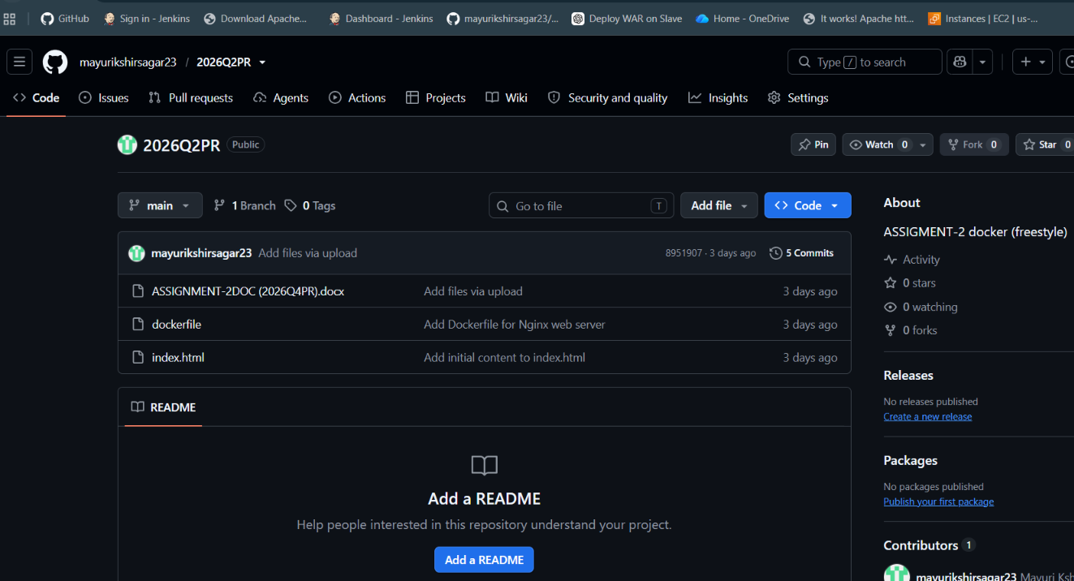
2)PIPELINE SCRIPT -IN JENKINS ---Q2-PIPELINE
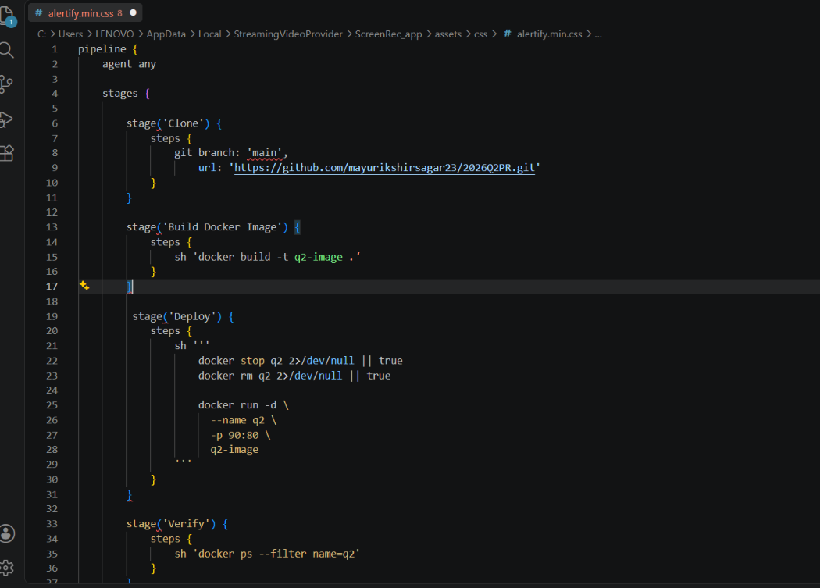

3)SUCESSFULLY BUILD IN JENKINS
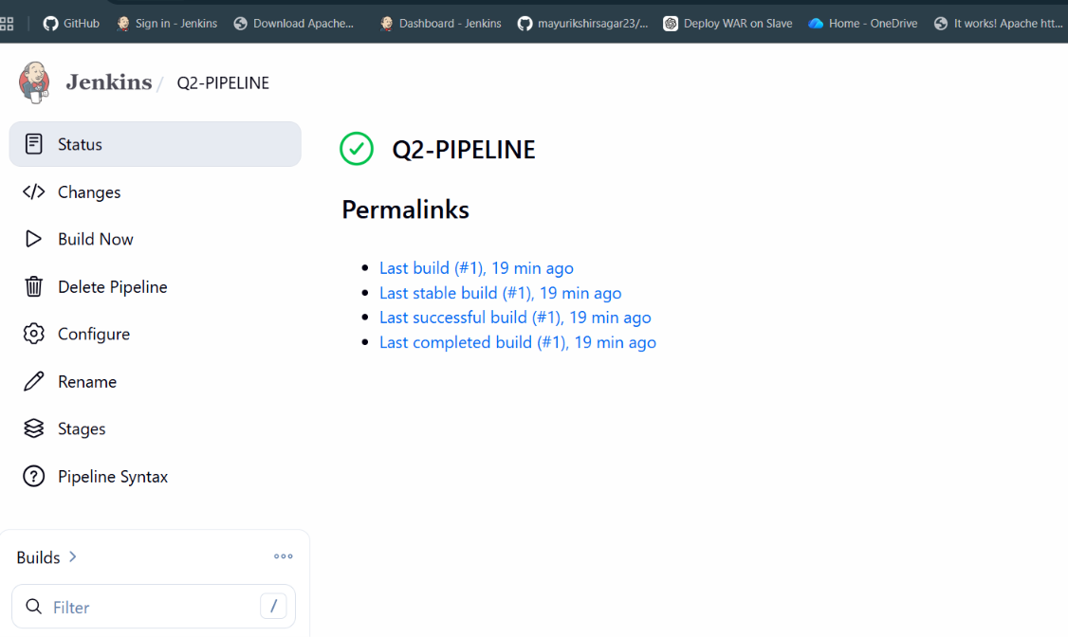
4)CHECKED ON EC2 q2 IMAGED WAS FORMED AUTOMATIC FROM JENKINS BUILD

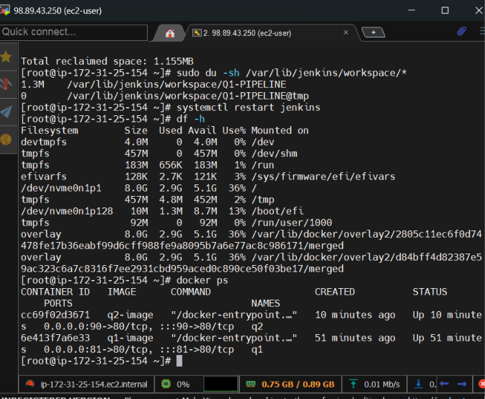

5)CHECKED ON BROWSER WITH – http://PUBLIC-IP:90
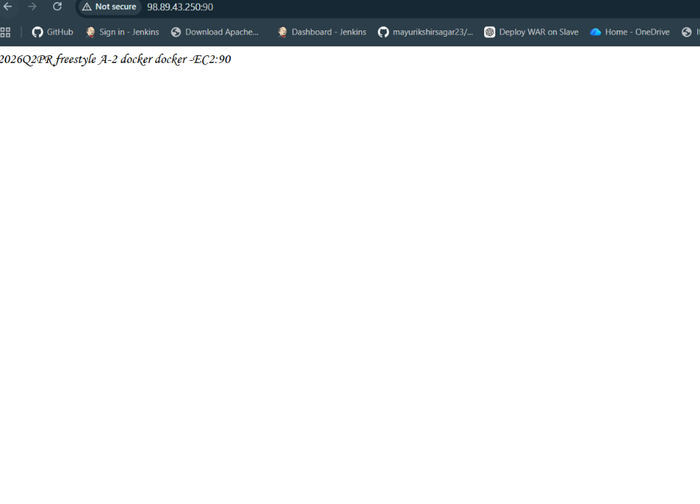
3)REPO --------- 2026Q4BF
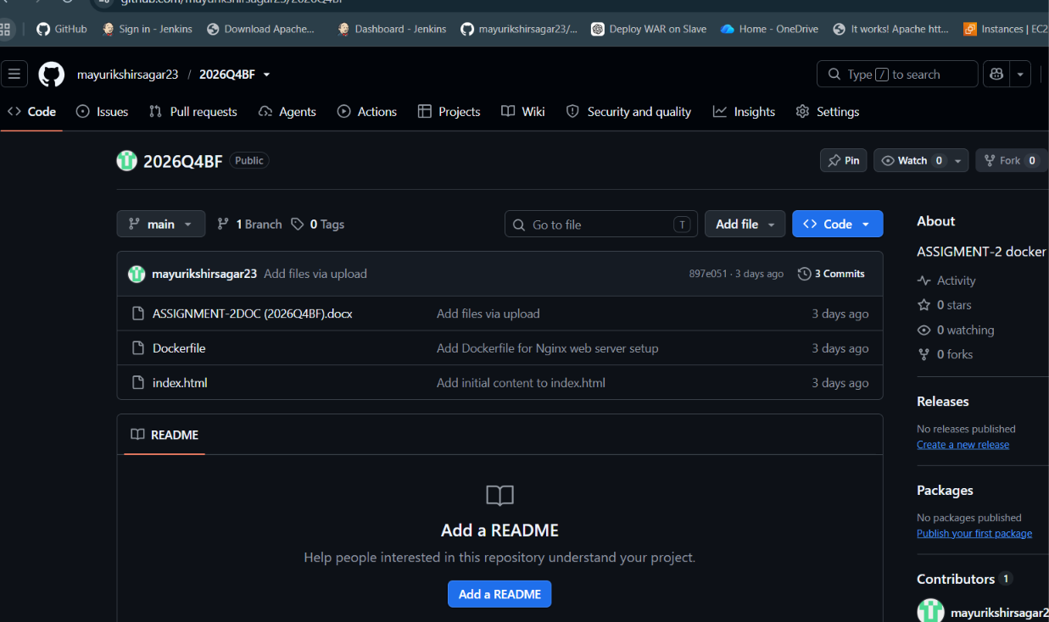

2)PIPELINE SCRIPT -IN JENKINS -Q4-PIPELINE
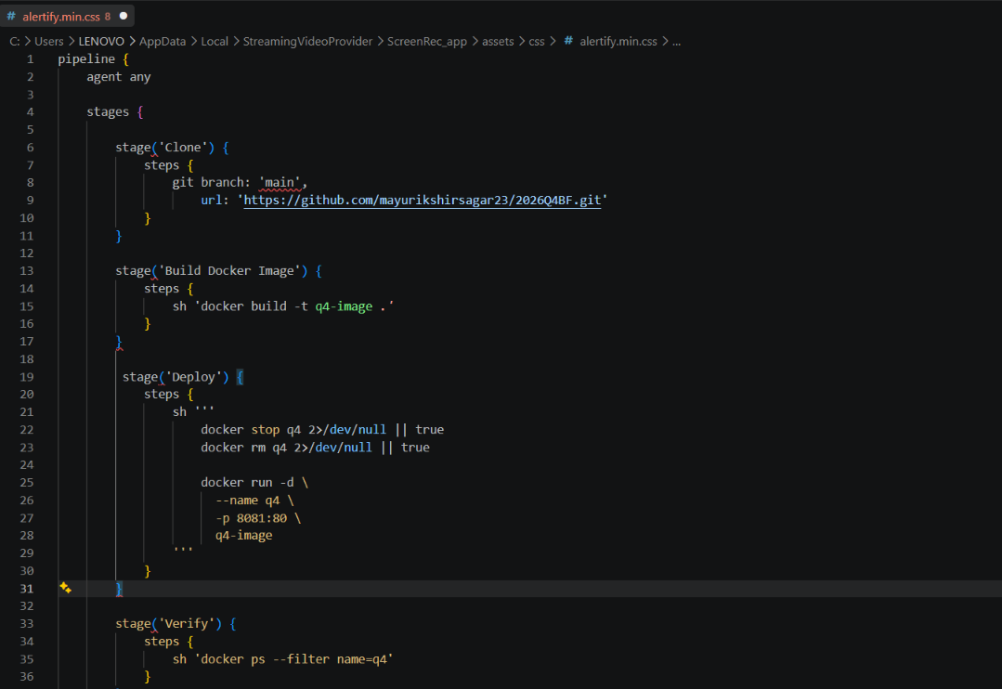
3)SUCESSFULLY BUILD IN JENKINS
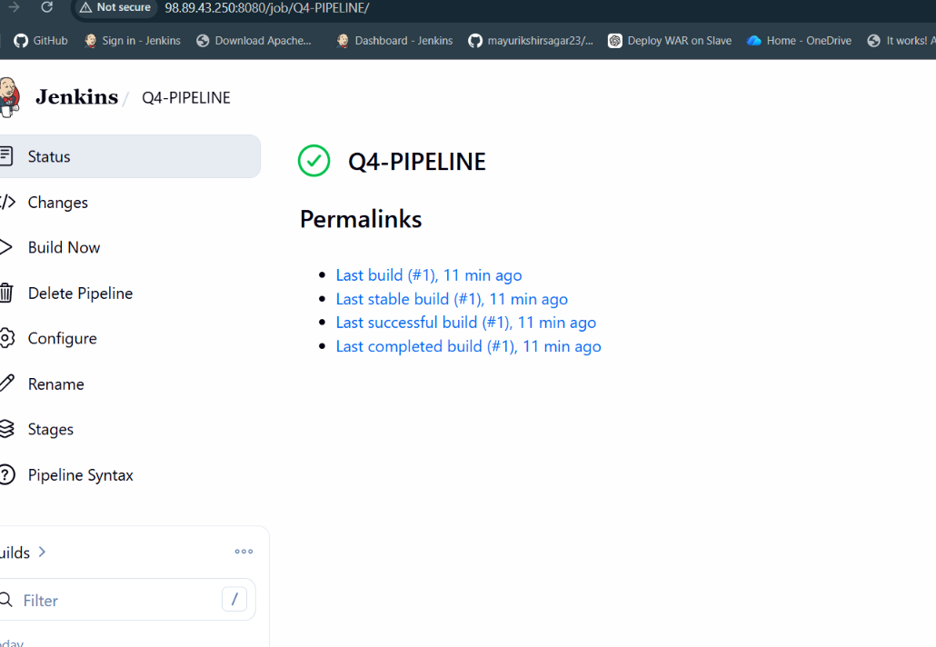
4)CHECKED ON EC2 q4 IMAGED WAS FORMED AUTOMATIC FROM JENKINS BUILD
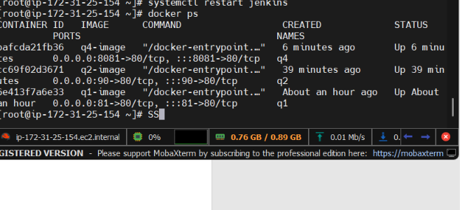

5)CHECKED ON BROWSER WITH – http://PUBLIC-IP:8081
